16.76: a)
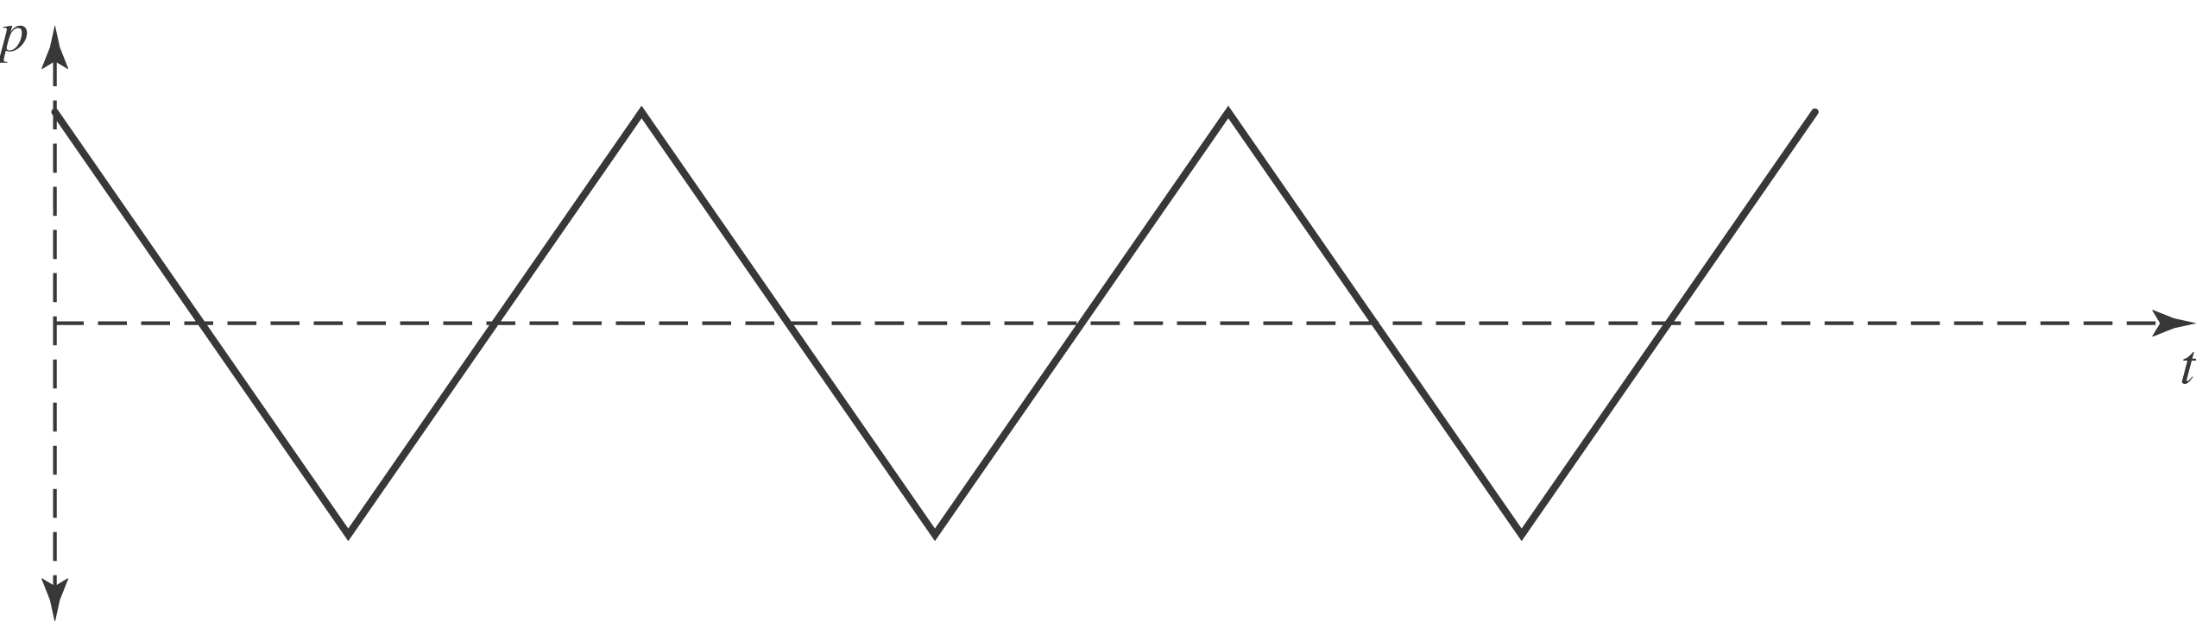

b) From Eq. (16.4), the function that has the given 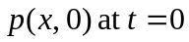 is given graphically as shown. Each section is a parabola, not a portion of a sine curve. The period is s and the amplitude is equal to the area under the 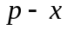 curve between 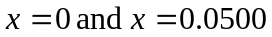 m divided by B, or 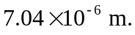

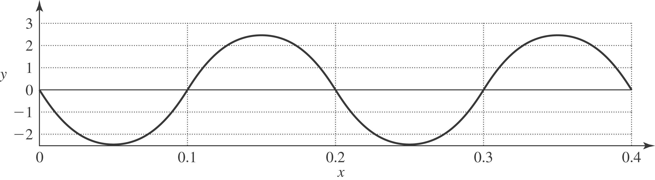

c) Assuming a wave moving in the 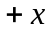-direction, 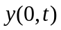is as shown.

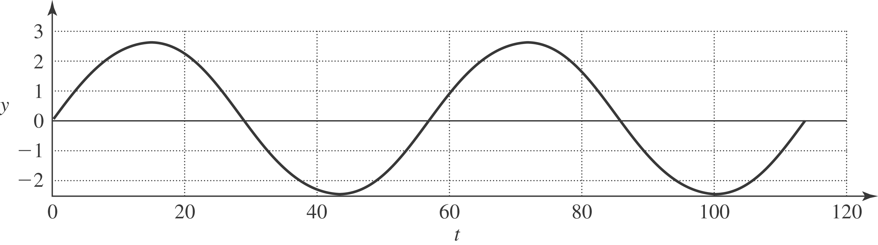

d) The maximum velocity of a particle occurs when a particle is moving throughout the origin, and the particle speed is 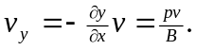 The maximum velocity is found from the maximum pressure, and The maximum acceleration is the maximum pressure gradient divided by the density,

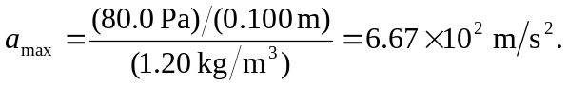

e) The speaker cone moves with the displacement as found in part (c ); the speaker cone alternates between moving forward and backward with constant magnitude of acceleration (but changing sign). The acceleration as a function of time is a square wave with amplitude 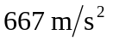 and frequency

